**PROJECT REPORT**

**ON**

**“TOURS AND TRAVELS”**

Project work submitted as partial fulfillment of the course for the Award of the degree

**BACHELOR OF COMPUTER APPLICATION**

**OF**

**BANGALORE UNIVERSITY**

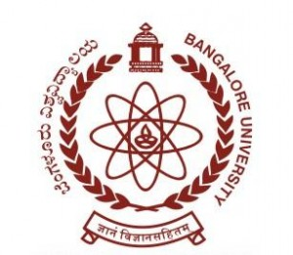

**SUBMITTED BY**

**Shyam N : 19P3SB7022**

**Under the Guidance of**

**(Prof. Raghavendra M Kulkarni)**



**PINNACLE INSTITUTE OF MANAGEMENT AND SCIENCE**

**Nagarabhavi 2nd Stage, Bangalore-560072**

**PINNACLE INSTITUTE OF MANAGEMENT AND SCIENCE**

**Nagarabhavi 2nd Stage, Bangalore-560072**

Certificate

**This is to Certify that Shyam N (19P3SB7022) BCA 5TH Semester in “Pinnacle Institute of Management and Science” has satisfactorily completed their project entitled “TOURS AND TRAVELS” as a fulfillment of requirements for requirements for the award of the degree in Bachelor of Computer Application awarded by Bangalore University for the academic year 2021-2022.**

**Signature of the Guide Signature of the Principal**

**(Prof. Raghavendra. M Kulkarni) (Prof. Kumarappa G.L)**

**ACKNOWLEDGEMENT**

It is not exaggeration to say that the emergence of this book was outcome of observing project. It not only involved number of days of efforts but also extensive consultation, case study, analysis, programming and much more. In fact, this project work enjoyed the creation and innovative support from the concerned guide.

I take this opportunity to express our sincere thanks to Prof. **Kumarappa G.L**, Principal for providing necessary facilities for the Project.

My sincere thanks to our Internal Guide **Prof. Raghavendra M Kulkarni** Professor in BCA Department, Pinnacle Institute of Management and Science, for his valuable suggestions, spontaneous encouragement and constant help in improving the presentation of this project.

I also like to thank our Principal, Lecturers, My parents and all our class mates, who have contributed directly or indirectly in our efforts to complete this project successfully.

With Gratitude

Shyam N [19P3SB7022]